Weekly Parent Focus Week Beginning: 2nd February
Vocabularly we learn and use this week:
R.E: Mary, Joseph, Jesus Maths: count, part, whole, altogether, how many, 1, 2, 3, 4, 5, 6, 7, 8, 9, 10 Topic: winter clothes hat, sticks, buttons, scarf, explorer, Ernest Shackleton, ship, Antarctica

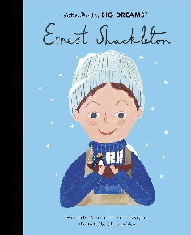

Focus story: Ernest Shackleton – Little people, big dreams
Rhyme of the week: The winter cokey rhyme

Our learning this week –
Phonics – This week we are focusing on qu and ch
R.E – This week we will continue with our new unit, People who care for us. The children will explore family relationships within the context of caring for one another. Importance is placed upon the value of celebration. This is further developed by hearing about times of celebration Jesus shared with his family and friends
Handwriting – This week we are practising our one armed robot letters – r, b, n, h, m, k, p
Our Maths Focus this week is:
This week we are using our part whole models again, this time we are using the two parts to find a whole. This is an introduction to addition.
___ is a part and ___ is a part. ____ is the whole. Altogether there are ___
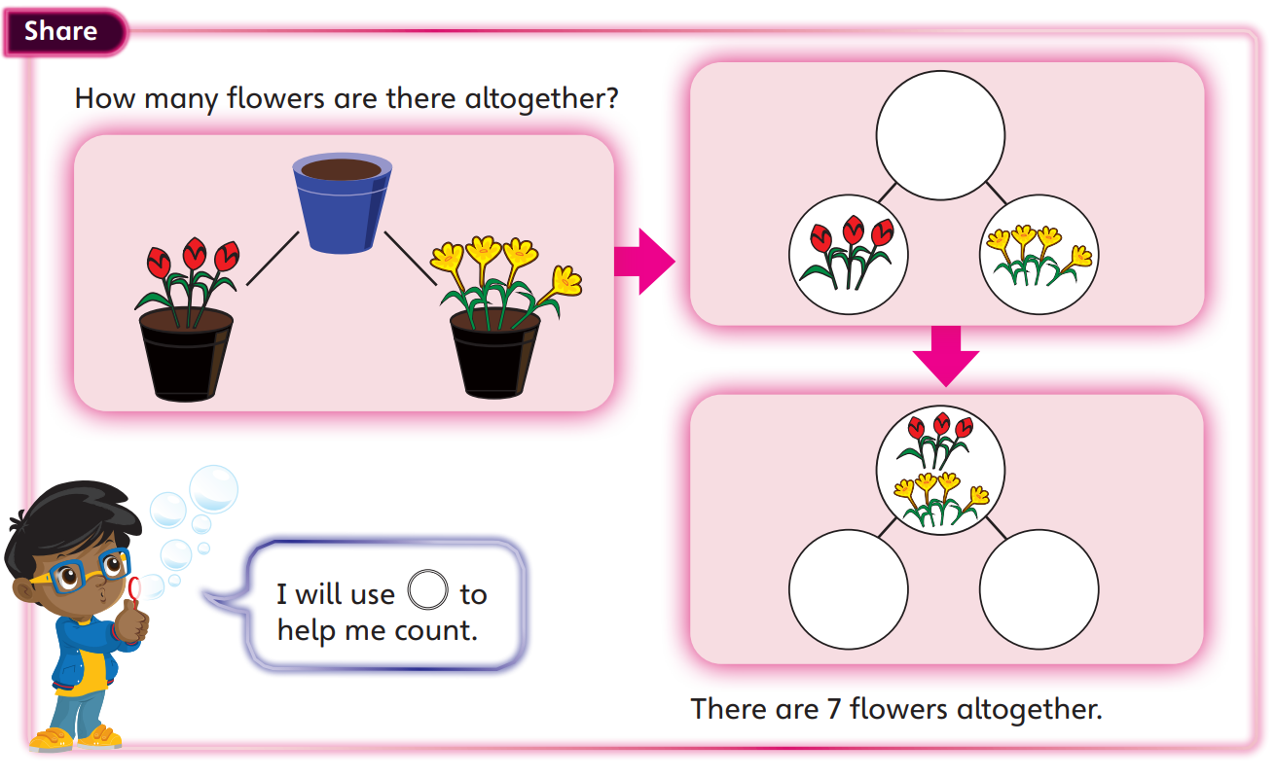

Toy fund
We thank you and appreciate any donations to our weekly 50p toy fund! This is so helpful for our resources and provision. Thank you

.
Things to remember:
- P.E will take place on Thursday afternoon this week.
- Please keep word purses and books in book bags each day so that we can read with the children in school



