Curriculum Information – Year Five – Spring 1

Class text | Oranges in No Man’s Land tells the riveting story of ten-year old Ayesha’s terrifying journey across no man’s land to reach a doctor in hostile territory in search of medicine for her dying grandmother. Set in Lebanon during the civil war, this story is told by award winning author Elizabeth Laird and is based on personal, real life events. | 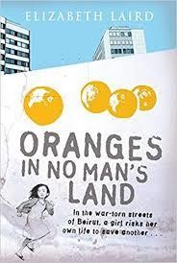
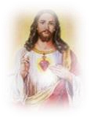  RE | Christmas: The children will learn the main features of the Christmas story and understand some of the difficulties faced by the Characters in the story.  Parables and Sayings of Jesus: The children will learn about the important Parables and Sayings of Jesus. They will also learn and understand that the Kingdom of God was part of the language used by Jesus to explain his preaching about welcoming and accepting God’s presence through him. They will also be thinking about some ways in which the Church lives out this teaching of Jesus.
English  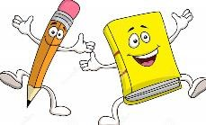 | Children’s Literacy work will link to our class text ‘Oranges in No Man’s Land’. The children will be using the text to explore emotive language and people’s responses to events such as war.  They will be using the text as a stimulus to write:  - a formal persuasive letter  - a newspaper report  - a diary of a child caught in the Lebanese civil war.
Maths  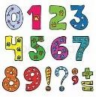 | In Maths the children will be focusing on multiplication and division, fractions and decimals.  They will learn how to:  - Multiply and divide numbers mentally drawing upon known facts  - multiply numbers up to 4 digits by a one- or two-digit number using a formal written method, including long multiplication for two-digit numbers  - Divide numbers up to 4 digits by a one-digit number using the formal written method of short division and interpret remainders appropriately for the context  - Multiply numbers up to 4 digits by a one- or two-digit number using a formal written method, including long multiplication for two-digit numbers  - Multiply proper fractions and mixed numbers by whole numbers, supported by materials and diagrams  - Recognise mixed numbers and improper fractions and convert from one form to the other and write mathematical statements > 1 as a mixed number  - Read, write, order and compare numbers with up to three decimal places  - Read and write decimal numbers as fractions [for example, 0.71 = 71/100]  - Recognise and use thousandths and relate them to tenths, hundredths and decimal equivalents  - Round decimals with two decimal places to the nearest whole number and to one decimal place  - Recognise the per cent symbol (%) and understand that per cent relates to ‘number of parts per hundred’, and write percentages as a fraction with denominator 100, and as a decimal  - Solve problems which require knowing percentage and decimal equivalents of 1 2, 1 4, 1 5, 2 5, 4 5 and those fractions with a denominator of a multiple of 10 or 25

It is vital that Y5 can recall number bonds to 10, 20 and
100 rapidly as well as their times tables up to 12 x 12(including division facts). All children have access to Times Table Rock Stars, which they can use at home.
Please support your child in practising these at home.

Science  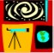 | How does the Earth and the other planets orbit the sun?  - Describe the movement of the Earth, and other planets, relative to the Sun in the solar system.  - Describe the movement of the Moon relative to the Earth.  - Describe the Sun, Earth and Moon as approximately spherical bodies.  - Use the idea of the Earth’s rotation to explain day and night and the apparent movement of the Sun across the sky.  The children with be working scientifically by reporting and presenting findings from enquiries; recording data and results of increasing complexity using scientific diagrams and labels, classification keys, tables, scatter graphs, bar and line graphs Identifying scientific evidence that has been used to support or refute ideas or arguments
Geography   | How is life in Mexico different to life in England?  Children will be studying Mexico this half term and comparing life there to life in England. Children will be able  to locate and identify countries of North and South America and compare other geographical aspects such as: climate, housing, population and the significance of rivers.
Art  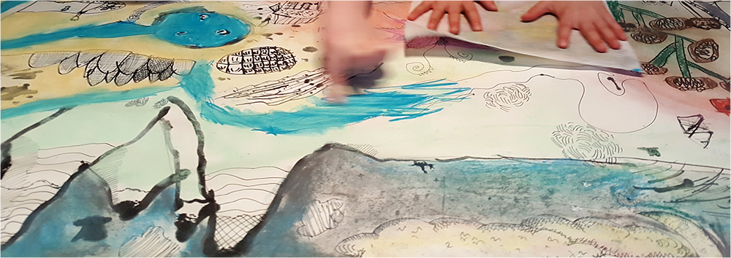 | Mixed Media Land and City Scapes  Children are introduced to the idea that artists don’t just work in studios, instead they get out into the world and draw and paint from life, inspired by the land and city scapes where they live.  They will see how artists use their creative freedom to explore ways of working which involve different materials and media.  Pupils are enabled to take creative risks and explore and experiment, without the pressure of having to “produce” and end result.
Computing   | Spreadsheets  Children will learn to create formulae to model and solve a given problem including using text variables.  They will then use their spreadsheet skills to plan out a cake sale.
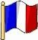  French | Shopping in France  In French this half term, the children will be expanding on their knowledge of numbers, looking at prices and then learning how to discuss what you buy when you go shopping. They will also be learning how to say different types of food and how to express their opinions towards them.

PE  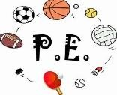 | PE will be taught on Monday afternoons; however, the children will need their P.E kits in school all week due to the weather.  The children will also be getting the opportunity to participate in Forest School on Wednesdays.
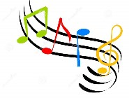  Music | - Children will continue to be taught by our specialist music teacher Mrs Amison on Wednesdays.  - The children will continue to develop their ukulele playing skills and focus on music in minor keys, understanding how the composer’s choice of chord can have an impact on the listener.
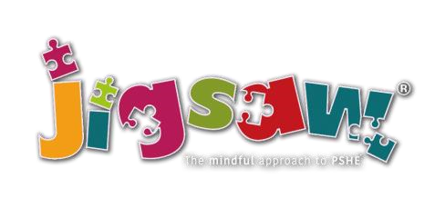  PSHE | Throughout the year, we will be continuing to follow the Ten:Ten ‘Life to the Full’ programme for RSHE. Please log into the parent portal to access information about the programme your children will be following, access to resources and suggestions for further activities at home.  www.tentenresources.co.uk/parent-portal/  You will need the following login credentials for our school:  Username: st-mary-st6  Password: vision24-st6
Key events for the half term
Homework | Children will continue to receive daily Maths and Literacy homework, which is to be completed each night.  On Thursdays, children will receive one piece of either Maths or English homework plus one piece of homework linked to a foundation subject (Art, Science, MFL, Computing, Music,  Geography, History etc). This will be due in on the following  Tuesday.

