Curriculum Information – Reception Class
Spring 1 - 2026


Welcome back to the Spring term! We are delighted to welcome you back and look forward to an exciting term! This term, the children will be exploring the season of winter and sharing a range of engaging texts, including the fictional story The Snowman. They will also be learning about the explorer Ernest Shackleton and his remarkable adventures. In addition, the children will be discovering and celebrating Chinese New Year, learning about its traditions and customs.
We are excited for all the learning and fun ahead!
Don’t forget to send in all your family observations using the ‘Evidence Me’ app as we love to see what other learning experiences your child is experiencing.

Thank you so much for all the wonderful evidence me photos we receive they are all wonderful!
A few points to remember:
- Please bring in book bags only (no rucksacks)
- Please bring in wellies in for the children to keep in school
- Please bring in a water bottle for your child to have – please label
- It is really important that all clothing and belongings are labelled with your child’s name. This will avoid any items being lost.
TOY FUND!
We love to keep resources nice and be able to buy resources when children have particular interests. We would like to ask for a donation of 50p a week for your child. This 50p would go towards new toys and learning resources for your children. This donation would be greatly appreciated if you are able to contribute. You can bring the 50p in weekly or if you would prefer to donate for the half term that is also fine.
Many thanks
The Foundation Stage Team
RE   | Our Class Saint this year is St Joseph  We will be learning all about St Joseph throughout the year and we will be celebrating his Feast Day on the Thursday 19th March.  This half term we will be learning about two very special units within our R.E.  Christmas  God our Father cares for us
English  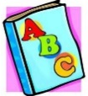 | We will explore many texts throughout this half term, some our focus texts will include:  The Snowman  Ernest Shackleton – Influential people  Lanterns and Firecrackers  Our writing opportunities will include:  Caption Writing and Tricky Words.  Writing some of the tricky words  Writing CVC words.  Labels using CVC words.  Guided writing based around developing short sentences in a meaningful context.  Create a story board.  Retelling stories in writing area.  Practising correct letter formation.
Phonics  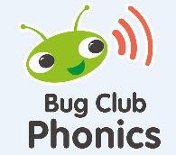 | Our reading opportunities will include:  Retelling through acting/role play.  Retelling stories using images / apps.  Editing of story maps and orally retelling new stories.  Sequence story – use vocabulary of beginning, middle and end.  Blend sounds into words, so that they can read short words made up of known letter– sound correspondences.  Reading short captions  Reading tricky words  Enjoying an increasing range of books.  Using actions to retell the story.  Creating our own story Maps.  This half term is a busy one for our phonics as we will be coming to end of Phase 2 and beginning to look at phase 3.  This term we will introduce:  Phase 3  Unit 7: y, z, zz, qu  Unit 8: ch, sh, th, ng  Unit 9: ai, ee, igh, oo (long) oo (short)  Decodable words: That, this, then, them, with, look, see, too  HFW: he, my, by, she, they, we, are, you,
Maths   | We will begin our first unit of Power maths and will be exploring:  - Numbers to 10  - Comparing numbers within 10  - Addition to 10  We will also be looking at recognising numbers and the formation of numbers
  Understanding of the World | This half term we will begin by continuing to explore Autumn and our exciting texts will help us to do this. The children will have to opportunities to explore these through our roleplays below.  Roleplay areas:  - Indoor - Homecorner – The children will have the opportunity to roleplay alongside their friends to take on roles around the home, problem solve and work together. This half term we will introduce babies and a pet into our home corner. This term we will add in babies and a home corner pet.  - Outdoor – Building area – large gross motor opportunities, labelling opportunities and creativity opportunities working together to solve problems  - Outdoor – Winter exploration – exploring signs of winter through our senses  - Pop up roleplays – these are roleplays that inetrest our children, this might mean we have a hairdressers, a builders yard, doctors, school and many more. We like to understand our children’s interests and use these within our play and learning.
Creative  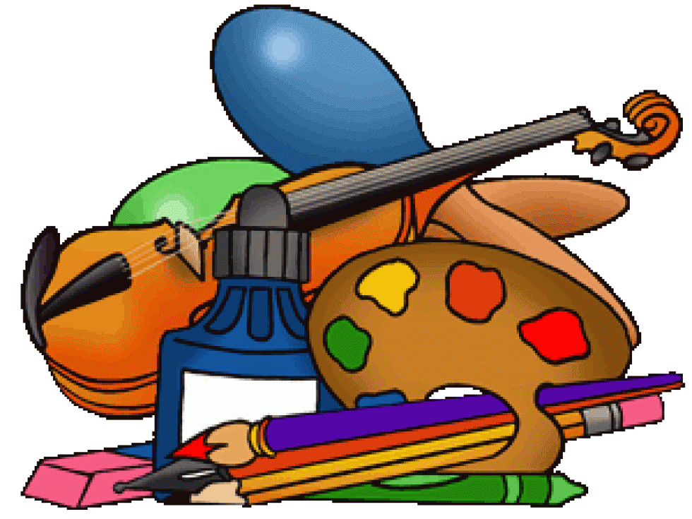 | Celebrations crafts: Chinese New Year  Winter tuff trays and activities  Outdoor provision  Exploring weather: Sensory  Freezing/melting  Winter clothes  Exploring weather: Sensory  Ice/snow/frost  Comparing Autumn to Winter – weather/animals/plants  Recycling materials – junk modelling  Exploring art and artists
Physical     | This half term some of the opportunities we will explore to develop our fine motor and gross motor skills will include:  Dough Disco  Squiggle while you wiggle  Fine motor opportunities –  - Dough disco, flags and streamers.  - Sensory writing – foam, sand, rice, glitter etc.  - Threading, cutting, weaving, playdough, Finger Gym/ chunky chalk activities.  - Fine motor construction, nuts bolts, crazy creatures, mobile.  - Large/small paint brush activities.  - handwriting practise -- Daily name  - writing activities  - cutting activities  - fine motor activities  - handwriting opportunities – sensory/on large paper/on lines  - Story drawings (talk for writing)  - Copying labels in the role play area/ continuous provision.  - Observational drawings.  - Clipboards for writing in continuous provision.  - Writing TD’s  - Scissor snipping activities – snipping play dough, bits of paper and card  Gross motor opportunities –  - Outdoor provision  - Sandpit  - Mud kitchen  - Outdoor balancing equipment/obstacle equipment  - balance bikes/wheelbarrows/scooters  - Large paintbrushes and water  - Large chalks  - Weekly P.E  - Monkey bars  - Large/small ball activities  - skipping ropes  - Flags and streamer/dance/music equipment  - Parachute games  Self-care – Using the toilet independently, hand washing independently, being independent at lunch times, dressing and undressing for P.E and Forest schools.  Please bring P.E kits into school.  This half term our P.E slot will be a Friday
Magic Moments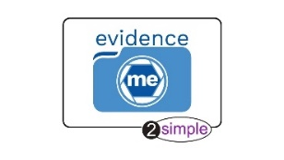 | Please continue to send in "Magic Moments" using the evidence me app when you feel that your child has learnt anything new as this will allow us to provide next steps in their learning.
Reading  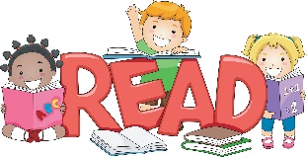 | Each week the children will have a focus story, a rhyme of the week (these will be found in our weekly parent newsletter)  The children will also bring home a library book each week (Wednesday). This will need to be returned each week. The children will choose their own library book.  Reception – Library book, picture book, word purse and school diary.  Please read school box at least 3x weekly and sign school diary.
Diary Dates  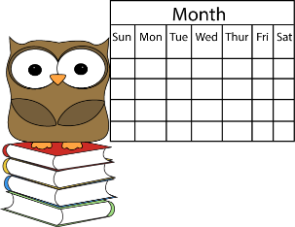 | Please refer to online school calendar.

