Curriculum Information – Year Three – Spring 1

Class text | 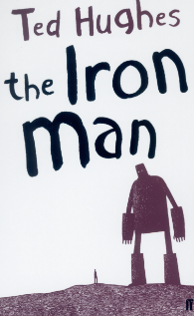  The Iron Man – Ted Hughes
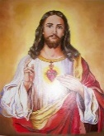  RE | Christmas  - In this unit the story of the shepherds provides a focus for children to reflect on the birth of Jesus Christ and who he is.  Reconciliation  - This unit involves the children exploring human choices, the consequences of sin, Christ’s teaching on forgiveness and the Sacrament of Reconciliation | 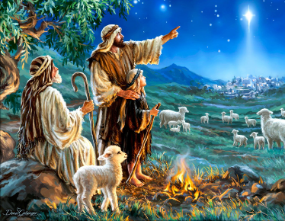  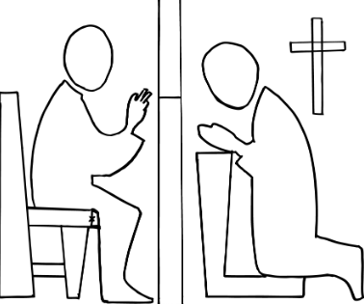
English   | Genre/Writing outcomes  Character description (The Iron Man)  - Role Play / Freeze frames for the Iron Man  - Begin to explore dilemmas for characters using drama  - Consolidate and use vocabulary from the book  - Annotate a picture of the Iron Man  - Use a and an correctly  - Use noun phrases (determiner, adjective and noun)  - Write sentences with more than one clause using a range of co-ordinating and subordinating conjunctions  - Use adverbs and prepositions in description  - Make simple additions, revisions and proof-reading corrections to own writing  Conversation between Hogarth and his dad (The Iron Man)  - Role play (dialogue) and hot seating to show understanding of character  - Discuss writing models similar to those they will use in their own writing to learn from its structure grammar and vocabulary.  - Use inverted commas to punctuate direct speech  - Use vocabulary of the characters in the story  - Use co-ordinating and subordinating conjunctions  - Use adverbs.  - Use the present perfect form of verbs instead of the simple past specifically in direct speech  - Make simple additions, revisions and proof reading corrections to own writing  Handwriting  - All diagonal and horizontal strokes are formed correctly.  - A fluent continuous cursive handwriting style is developing through increased legibility, consistency and quality of presentation.
Maths   | Multiplication and Division  - solve problems, including missing number problems, involving multiplication and division, including positive integer scaling problems and correspondence problems in which n objects are connected to m objects  - Write and calculate mathematical statements for multiplication and division using the multiplication tables that they know, including for two-digit numbers times one-digit numbers, using mental and progressing to formal written methods  - Solve problems involving addition, subtraction, multiplication and division and a combination of these, including understanding the meaning of the equals sign  Money  - Add and subtract amounts of money to give change, using both £ and p in practical contexts  Statistics  - interpret and present data using bar charts, pictograms and tables  - Solve one-step and two-step questions [for example, 'How many more?' and 'How many fewer?'] using information presented in scaled bar charts and pictograms and tables
  Science | How do magnets work?  Forces and Magnets  - Compare how things move on different surfaces  - Notice that some forces need contact between two objects, but magnetic forces can act at a distance  - Observe how magnets attract or repel each other and attract some materials and not others  - Predict whether two magnets will attract or repel each other, depending on which poles are facing. Describe magnets as having two poles  - Compare and group together a variety of everyday materials on the basis of whether they are attached to a magnet, and identify some magnetic materials  Working scientifically  - Know how to set up a test to compare two things  - Know how to identify differences, similarities and changes related to an enquiry  - Know how to ask relevant Scientific questions  - Know how to set up a simple enquiry to explore a scientific question |   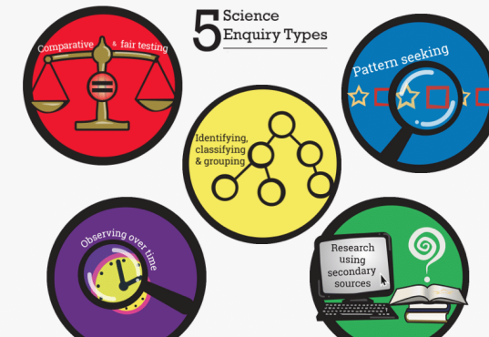
History | What is the Iron Age?  - Know how Britain changed between the beginning of the Stone Age and the Iron Age  - Know the main differences between the Stone, Bronze and Iron Ages | 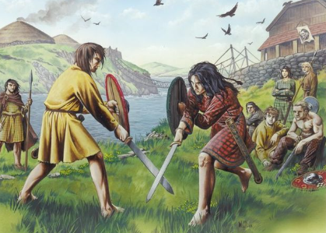
Art | Working with shape and colour  Can I make artwork just like Henri Matisse?  - Children will be inspired by key artworks and make their own work in creative response using shape and colour as a way to simplify elements of the world.  - They will recognise that shapes have both a positive and negative element and will arrange shapes to create exciting compositions.  - Children will build up imagery through layering shapes and will use collage to inspire prints. | 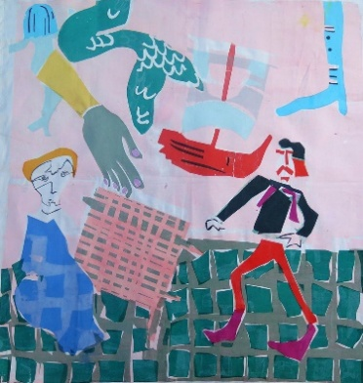
PSHE   | Life to the Full – RSHE  - Created and Loved by God – this unit explores the individual. Rooted in the teaching that we are made in the image and likeness of God, it helps children to develop an understanding of the importance of valuing themselves as the basis for personal relationships.  - Created to Love Others – This unit explores the individual’s relationship with others. Building on the understanding that we have been created out of love and for love, this module explores how we take this calling into our family, friendships and relationships, and teaches strategies for developing healthy relationships and keeping safe both online and in our daily lives. |   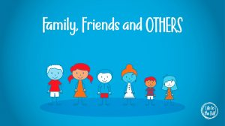
Computing   | - Basic elements of touch typing  - How to safely use Email – including email safety | 
PE   | Health Related Exercise  - Develop children’s knowledge of how the body functions/changes during exercise  - Develop children’s ability to exercise at different intensities. | 
  Music | Over the next half term, children will start to explore semiquaver rhythms.  They will also listen and respond to examples of Music in 2- or 3-time.  Recorder and music lessons will continue to take place on a Wednesday. | 
Homework | Daily Homework  - Daily Maths homework will be five questions practicing the four basic operations and include one word problem. They should be completed and returned daily.  - Daily English homework will support the development and enrichment of vocabulary. Words will be taken from the No-nonsense spelling scheme, class texts and Year 3 / 4 curriculum spelling lists.  Weekly Homework  - Children will receive one piece from either Science, History, Geography, Art, DT, Computing or PSHE (these subjects will be rotated throughout the term).  - Homework is handed out on a Thursday and handed in on Monday.  - An additional Maths or English homework will be given alternately each week.  Reading Diaries  - Children are encouraged to read at home daily (for at least 20 minutes) and are expected to have their diaries signed by an adult at least 3 times a week.  PE  - Please ensure that full kit stays in school all week throughout the term. Children may participate in PE lessons frequently throughout the week, which may take place outdoors (weather permitting). Trainers suitable for outdoors and a school PE hoodie and navy jogging bottoms would be helpful.  Forest School  - This half term, Year 3 will be taking part in Forest School every Wednesday linking our topics of The Iron Age and Forces and Magnets to our natural world.  - Please provide a change of warm, waterproof and weather-appropriate clothing and boots or wellies each week. These sessions will take place outdoors and in ALL weather conditions.

