Curriculum Information – Year Two – Spring 1

Class text | Fantastic Mr. Fox  The Owl who was Afraid of the Dark.  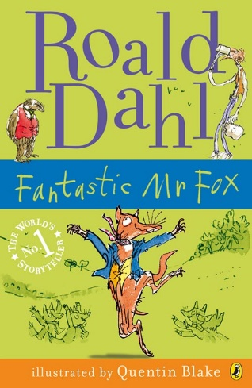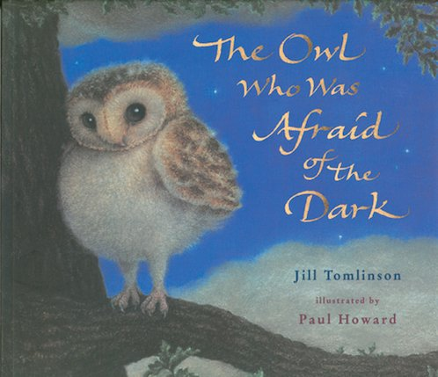
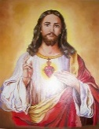  RE | Christmas  We will start the term by continuing the Christmas story with the visit of the three wise men and Mary, Joseph and Jesus’ flight to Egypt.  We will continue to look at Jesus’ life through his teaching of parables and his show of God’s powers through his miracles. We will explore what these stories tell us about Jesus and how we can use these teaching in our lives.  Parables and Miracles  In this unit we will develop our understanding of Jesus’ parables and miracles. Through these we will develop a greater understanding of who  Jesus is and what his ministry was. | 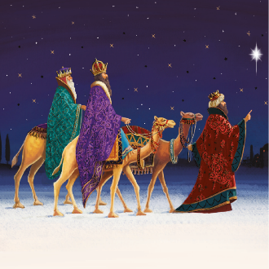  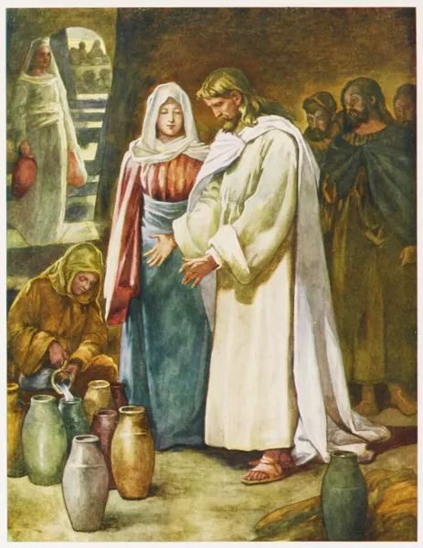
English   | Through a variety of texts, children will:  Orally re-tell familiar stories using narrative structure and dialogue from the text  Dramatise parts of the story.  Plan a different character and setting for the story  Use phrases drawn from story language to add interest  Subordination and co-ordination (using or, and, but)  Expanded noun phrases for description and specification  Write statements, question, exclamation and commands  Ensure correct choice and consistent use of present tense and past tense throughout writing  Use of the progressive form of verbs in the present and past tense to mark actions in progress  Use of capital letters, full stops, question marks and exclamation marks to demarcate sentences  Commas to separate items in a list  Apostrophes to mark where letters are missing in spelling  Apostrophes to mark singular possession in nouns  Write innovative story with a logical sequence of events, using complete sentences grouped together to tell the different parts of the story.
Maths   | Money  - Recognise and use symbols for pounds (£) and pence (p); combine amounts to make a particular value.  - Recognise and know the value of different denominations of coins and notes.  - Find different combinations of coins that equal the same amounts of money.  - Solve simple problems in a practical context involving addition and subtraction of money of the same unit, including giving change.  Multiplication and Division  - Solve problems involving multiplication and division, using materials, arrays, repeated addition, mental methods, and multiplication and division facts, including problems in contexts  - Solve one-step problems involving multiplication and division, by calculating the answer using concrete objects, pictorial representations and arrays with the support of the teacher  - Calculate mathematical statements for multiplication and division within the multiplication tables and write them using the multiplication (×), division (÷) and equals (=) signs  - recall and use multiplication and division facts for the 2, 5 and 10 multiplication tables, including recognising odd and even numbers  - Solve problems involving multiplication and division, using materials, arrays, repeated addition, mental methods, and multiplication and division facts, including problems in contexts
  Science | How will 5-a-day make me healthy?  - Know what animals and humans need to survive.  - Describe the importance for humans to exercise, eating the right amount of different types of food and hygiene. | 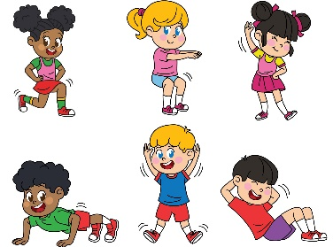
Geography   | Would you rather live in Stoke-on-Trent or Sydney?  - Know the names of and locate the seven continents of the world using maps, globes and atlases.  - Know the main differences between a place in England and that of a small place in a non-European country.  - Know and use locational and directional language (including 4 compass points) such as: left and right; near and far to describe the location of features and routes on maps and/or aerial photographs.. | 
Art   | Expressive Painting  - See how artists, contemporary and old masters, sometimes use paint in an expressive, loose way to create paintings full of life and colour.  - Start to share my response to the work of other artists.  - Use my sketchbook to fill full of colour and brush marks, inspired by other artists.  - Recognise primary colours and mix secondary colours. I can experiment with hues by changing the amount of primary colours I add.  - Use various home-made tools to apply paint in abstract patterns. I can be inventive.  - Make a loose drawing from a still life.  - See colours and shapes in the still life.  - Use my gestural mark making with paint, and incorporate the colours and shapes in the still life to make an expressive painting.  - Share my experiments and final piece with others and share what I liked and what went well.  - Enjoy the work of my classmates and I can see how all the work is different. I can share my response to some of their work.  - Take a photograph of my final piece, thinking about focus and lighting. | 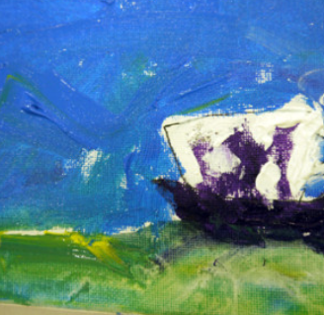
Computing   | Questioning  - To show that the information provided on pictograms is of limited use beyond answering simple questions.  - To use yes/no questions to separate information.  - To construct a binary tree to separate  different items.  - Use 2Question (a binary tree) to answer questions.  - To use a database to answer more complex search questions.  - To use the Search tool to find information. | 
PE   | Health-Related Exercise  Develop children’s knowledge of how the body functions/changes during exercise​  Develop children’s ability to exercise at different intensities | 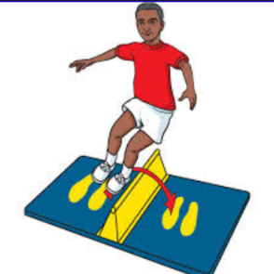
  Music | - Music continues to be taught by Mrs Amison  - To know and identify instrumental timbre groups  - Identify and follow basic song structure; verse and chorus | 
PSHE | This term we will be following the Ten:Ten ‘Life to the Full’ programme for RSHE. We will be looking at Gospel reflections on Jesus welcoming little children to Him, helping pupils to remember that they’re all special because they are made and loved by God. Children will be encouraged to notice similarities and celebrate differences between fictional people and each other as things that make us unique and special. We will then be looking at celebrating our God-given bodies and the things they enable us to do. In an age-appropriate way, children will be encouraged to notice similarities and celebrate differences between girls and boys on physical, emotional and spiritual levels. Building from this session where children learned that our bodies are good, this session teaches children how to take care of their bodies. Children will meet Super Susie and help teach her how to take care of herself. They will finish the unit with a recap reminding the children that their bodies are a special gift from God that they need to look after. | 
Homework | Daily Homework  - Daily Maths homework will be four questions practicing the four basic operations.  - Daily English homework will support the development and enrichment of vocabulary. Words will be taken from class texts or stories read in school. It is given out on a Monday and collected on a Friday.  Weekly Homework  - Children will receive one piece from either Science, History, Geography, Art, DT, RE, Computing or PSHE (these subjects will be rotated).  - Homework is handed out on a Monday and handed in on Friday.  Reading Diaries  - Children are encouraged to read at home daily (for at least 20 minutes) and are expected to have their diaries signed by an adult at least 3 times a week.

