Curriculum Information – Year One – Spring 1
Thank-you so much for all of your well wishes, cards and gifts; we are very grateful and we hope that you have all had a great Christmas time with your families!

Class text | We will be exploring our topic ‘Polar Adventures!’ and thinking about life in the South, and North Pole. We will be focusing upon the story ‘Lost & Found’ written by Oliver Jeffers along with other popular texts such as ‘The Snow Queen’ and ‘The Snail & The Whale’, a classic written by our class favourite author, Julia Donaldson. | 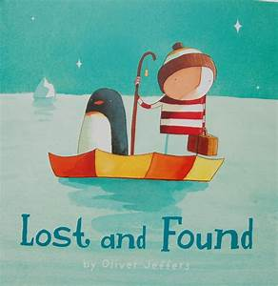
RE   | Following on from our Advent focus we will be looking at the wonderful Christmas Story, focusing upon The Holy Family, the visitors to the stable and the best Christmas present of all, Our Lord, Jesus Christ!  Then we will be thinking about how we can share in the life of Jesus today! | 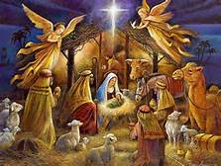
  RSHE  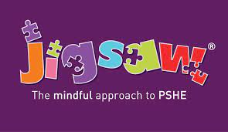  PSHE | We will be continuing to explore our religious, social, emotional and personal health by working through units led by Ten: Ten and the Jigsaw Program; the units that we will be focusing on are;  Special People Treat Others Well… and say sorry Keep trying even when it is difficult Have a positive attitude | 
English   | We will be continuing to enjoy stories, linked to our topic, written by our class author, Julia Donaldson amongst other authors  - We will continue to apply the basics of writing; letters and sounds – recognition and representation, handwriting – correctly formed and positioned, demarcated sentences – capital letters and end marks.  - We will also be focusing upon the grammatical feature of adjectives – a word that describes a noun / pronoun.  - We will also begin to look at rhyme, through storytelling, poetry and songs.
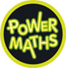  Maths | We will be continuing to teach Mastery in Maths, following the Power Maths Scheme.  This term we will be continue to work with adding and subtracting, using numbers up to 20.  work with your number bond cards at home to help you out with this!
  Science | ‘How does your garden grow?’  We will be completing observations, data collection and tasks to help us further understand about the features of plants and trees and the important part played by the weather linked to the seasons.  - Identify and describe the basic structure of a variety of common flowering plants, including trees  - Identify and name a variety of common wild and garden plants, including deciduous and evergreen trees.  - I observe changes in the seasons / know how they are different. | 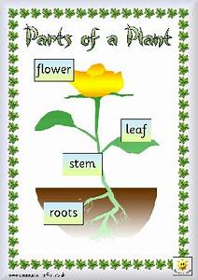
  Geography | Is it the same all around the world?  We will be learning about our world, finding out about what it might be like to live in hot and cold climates; we will be looking closely at Africa and the Polar Regions. | 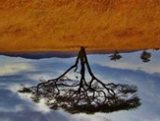  
  ART | Let’s learn all about printmaking!  We will be exploring printmaking. We will be using our knowledge of colour to explore the negative an the positive image whilst printing with a wide range of materials and tools onto a variety of surfaces. | 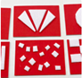
Computing   | Let’s continue to build our IT skills!  We will be continuing to work through the Purple Mash syllabus for Year 1, completing ‘Pictograms’ and ‘Lego Builders’ units and beginning ‘Maze Explorers’. | 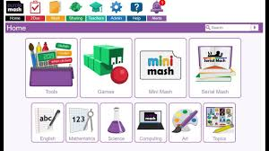
  PE | Gymnastics  We will have our PE lessons on a Monday afternoon and we will be learning all sorts of different ways to balance. The children will begin to refine movements into actions showing control, extension and a degree of fluency.  Please ensure that your correct, labelled PE kit is in school and available at all times. | 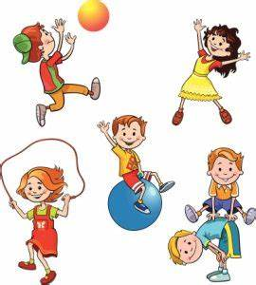
Music   | Music  We will be taking turns to sing & play using echoes and call & response. We will identify echoes and repetition in the music that we hear and also move to the music to show the pulse. Using stick notation, we will develop the concept of rhythm using crotchet notes & rests. We will create rhythms in response to wintery pictures, sequencing them to create a group performance. | 
Homework | - Daily Maths (little blue book focusing on the 4 operations)  - Daily Handwriting Practise (little yellow books)  - Foundation Subjects (purple books, compulsory, weekly)  - Home Reading (3 x weekly, please ensure that you sign the diary)  - Bugs Club – I have posted some books for your child onto the site  - Purple Mash – I have posted some To Do’s for your child onto the site

